IMAN NOOR

BYTEWISE FELLOWSHIP DATA SCIENCE

GROUP II

🔴 TASK 1 -> an introduction to Git. This will include installing Git and learning some basic commands: init, add, and commit.

1. INTRODUCTION

Git is a popular version control system. It is used for:

* Tracking code changes
* Tracking who made changes
* Coding collaboration

1. INSTALLATION

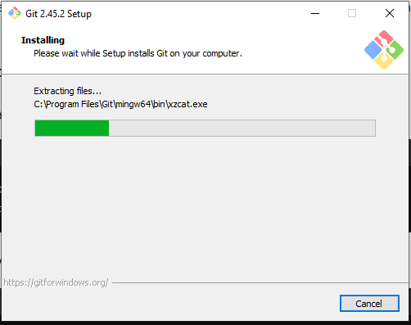

1. GIT COMMANDS

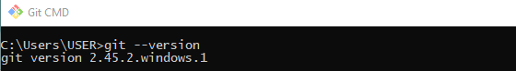

Configure Git:



Git folder creation and initialization:

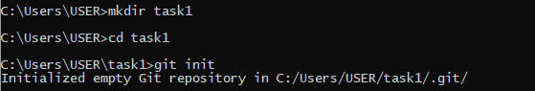

Git status:

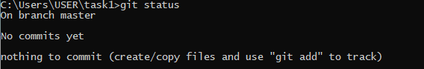

Adding files:



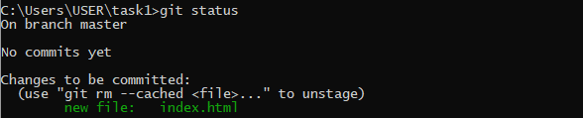



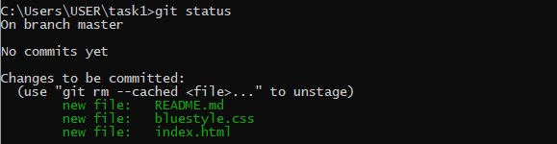

Commit changes:

